On Friday May 5th, children’s author Kirby Larson will be coming to visit Spiritridge Elementary.
Following her presentations, she will be signing and personalizing copies of her books.
If you would like to order a book, please fill out the form below, and return it to the school by April 20th.

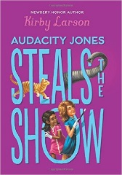  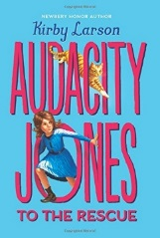 | Audacity Jones Steals the Show (hard cover)  Audacity Jones and her best friend, Bimmy, are setting off from Miss Maisie's School for Wayward Girls on an extraordinary adventure! In the glittering city of New York, the girls meet Harry Houdini, the world's most famous magician, as he prepares a new spectacle: Houdini plans to make an elephant disappear from a crowded theater. But Audacity and Bimmy discover a nefarious plot that puts Houdini's illusion in jeopardy. Who could be trying to sabotage the master magician? Audie will need all her smarts, the help of friends new and old, and even her best juggling skills to solve this mystery. Will she manage to save the show in time?  Audacity Jones to the Rescue (paperback)  Audacity Jones is an eleven-year-old orphan who aches for adventure, a challenge to break up the monotony of her life at Miss Maisie's School for Wayward Girls. Life as a wayward girl isn't so bad; Audie has the best of friends, a clever cat companion, and plenty of books to read. Still, she longs for some excitement, like the characters in the novels she so loves encounter.
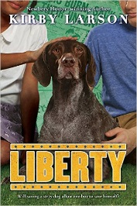 | Liberty (hard cover)  Can saving a stray dog allow one boy to save himself?  Fish has a knack for inventing. His annoying neighbor Olympia has a knack for messing things up. But when his latest invention leads Fish to Liberty, a beautiful stray dog who needs a home, he and Olympia work together to rescue her. As Fish enlists the help of unexpected friends and allies to save Liberty, he finds her perceptions of the world – of race and war, family and friendship – transformed.
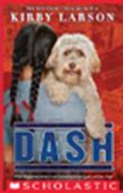 | Dash (paperback)  Although Mitsi Kashino and her family are swept up in the wave of anti-Japanese sentiment following the attack on Pearl Harbor, Mitsi never expects to lose her home -- or her beloved dog, Dash. But, as people of Japanese descent are forced into incarceration camps, Mitsi is separated from Dash, her classmates, and life as she knows it. The camp is a crowded and unfamiliar place, whose dusty floors, seemingly endless lines, and barbed wire fences begin to unravel the strong Kashino family ties. With the help of a friendly neighbor back home, Mitsi remains connected to Dash in spite of the hard times, holding on to the hope that the war will end soon and life will return to normal. Winner of the Scott O’Dell Historical Fiction Prize.
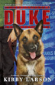 | Duke (paperback)  A poignant World War II story about a boy and his dog and his dad, and the many meanings of bravery. With his father fighting overseas in Europe, eleven-year-old Hobie Hanson is determined to do his part to help his family and his country, even if it means giving up his beloved German shepherd, Duke. Hobie donates Duke to Dogs for Defense, an organization that urges Americans to "loan" their pets to the military to act as sentries, mine sniffers, and patrol dogs.  Hattie Big Sky (paperback)  Alone in the world, teen-aged Hattie is driven to prove up on her uncle's homesteading claim.  For years, sixteen-year-old Hattie's been shuttled between relatives. Tired of being Hattie Here-and-There, she courageously leaves Iowa to prove up on her late uncle's homestead claim near Vida, Montana. With a stubborn stick-to-itiveness, Hattie faces frost, drought and blizzards. Despite many hardships, Hattie forges ahead, sharing her adventures with her friends--especially Charlie, fighting in France--through letters and articles for her hometown paper.
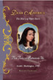 | Dear America, the Diary of Piper Davis – The Fences Between Us (hard cover)  With this sweeping tale of life on the World War II home front, Newbery Honor author Kirby Larson brings her incredible talent to the Dear America series. When Pearl Harbor is attacked, America is finally unable to ignore the wars in Europe and Asia any longer. And one girl's entire life is about to change when everything she knows is turned on its head. After the devastating attack on Pearl Harbor, where her brother, a navy sailor, is stationed, Piper Davis begins chronicling her compelling journey through one of history's most tragic and unforgettable eras.
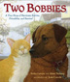 | Two Bobbies (hard cover)  Bobbi and Bob Cat are the best of friends. When their hometown of New Orleans was struck by Hurricane Katrina, many lost everything. But Bobbi and Bob Cat still had each other. Only by staying together could they survive. This is the story of their remarkable friendship. The authors are donating 10% of their proceeds to Best Friends Animal Society (BFAS). Winner of Henry Bergh ASPCA Award and 15 state Young Readers Choice Awards.
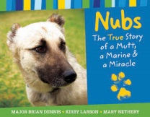 | Nubs: The True Story of a Mutt, A Marine and a Miracle (hard cover)  Nubs, an Iraqi dog of war, never had a home or a person of his own. He was the leader of a pack of wild dogs living off the land and barely surviving. But Nubs’ life changed when he met Marine Major Brian Dennis. Nubs and Dennis will remind readers that friendship has the power to cross deserts, continents, and even species. Winner of the Christopher Medal and 15 state Young Readers Choice Awards
STUDENT NAME:___________________________________TEACHER/GRADE:________
PARENT CONTACT (phone): ________________________________________________

Title | # of Copies | Price | Total  $ |  |  | Autograph  Only | Or Personalize to:
Audacity Jones Steals Show (hard cover) |  | $16.99
Audacity Jones (paperback) |  | $6.99
Liberty (hard cover) |  | $ 16.99
Dash (paperback) |  | $7.99
Duke (paperback) |  | $7.99
Hattie Big Sky (paperback) |  | $7.99
Dear America (hard cover) |  | $12.99
Two Bobbies (hard cover) |  | $ 16.99
Nubs (hard cover) |  | $18.00
Sub-total (pre-tax).  Total including 10% sales tax. |  |  |  |  | $  $ |  | EXACT CASH ONLY.  CHECKS PAYBALE TO ISLAND BOOKS.
PLEASE PUT PAYMENT IN SEALED ENVELOPE LABELED KIRBY LARSON AND RETURN TO OFFICE BY APRIL 20th.

